**EMAIL SPAM DETECTION FOR NETWORK SECURITY**

1. **INTRODUCTION**

In today's interconnected world, email communication has become an integral part of both personal and professional interactions. However, with the increasing volume of emails being sent and received daily, the issue of spam emails has grown to be a significant concern. Email spam, often used for various malicious purposes, poses substantial threats to network security, data integrity, and user productivity. In response to this challenge, the development of robust email spam detection systems has become crucial in safeguarding our digital ecosystem.

Email spam refers to unsolicited, irrelevant, or potentially harmful messages that inundate email inboxes. These spam emails are designed to deceive recipients, spread malware, steal personal information, or promote fraudulent schemes. As a result, they can lead to financial losses, data breaches, and security vulnerabilities for individuals and organizations.

Email spam detection plays a pivotal role in protecting network security by identifying and filtering out spam emails before they reach the intended recipients. Through the application of advanced techniques such as machine learning, natural language processing, and heuristics, these systems strive to distinguish legitimate emails from spam, thereby reducing the risks associated with malicious email content.

This introduction sets the stage for a comprehensive exploration of email spam detection in the context of network security. We will delve into the mechanisms and technologies used in spam detection, examine the evolving tactics employed by spammers, and discuss the importance of staying ahead in the ongoing battle against email spam. By understanding the complexities and nuances of this critical aspect of cybersecurity, we can better equip ourselves to combat the ever-present threat of spam emails and enhance the overall security of our networks.

1. **PROJECT DESCRIPTION**
   1. **EXISTING SYSTEMS**

Machine Learning Algorithms: Machine learning plays a significant role in modern spam detection systems. Techniques like supervised learning (e.g., Naive Bayes, Support Vector Machines), unsupervised learning (e.g., clustering algorithms), and deep learning (e.g., neural networks) are used to analyze email content and sender behavior.

* 1. **PROPOSED SYSTEM**

1. Data Collection:

Collect a diverse dataset of both spam and legitimate emails. This dataset will be used for training and testing the spam detection model.

2. Preprocessing:

Preprocess the collected data, including email content, email headers, and sender information. This may involve text cleaning, tokenization, and feature extraction.

3. Feature Engineering:

Extract relevant features from the email data. These features can include word frequencies, sender reputation, email header attributes, and more.

4. Machine Learning Model:

Implement a machine learning model for email spam detection. Depending on the project's scale and resources, you can choose from various algorithms like Naive Bayes, Support Vector Machines, or deep learning models.

5. Training:

Train the machine learning model on the preprocessed dataset. This training should involve a combination of labeled spam and non-spam emails.

6. Real-time Analysis:

Integrate the trained model into a real-time email processing pipeline. As emails are received, they should be analyzed for spam content in real-time.

1. **METHODOLOGY**

**3.1 STEPS**

1. Project Initiation:

Define the project's scope, objectives, and expected outcomes.

Establish a project team with the necessary skills in machine learning, data preprocessing, email analysis, and network security.

2. Data Collection:

Gather a diverse dataset of both spam and legitimate emails. Consider using publicly available datasets and, if possible, collect data specific to your organization.

3. Data Preprocessing:

Clean and preprocess the email data, which includes text cleaning, tokenization, and feature extraction.

Handle missing data and perform any necessary data transformations.

4. Feature Engineering:

Extract relevant features from the email data, such as word frequencies, sender reputation scores, email header attributes, and more.

5. Machine Learning Model Selection:

Choose the appropriate machine learning algorithm(s) for email spam detection. Options include Naive Bayes, Support Vector Machines, deep learning models, or a combination of these.

6. Data Splitting:

Split the dataset into training, validation, and test sets to train and evaluate the machine learning model.

7. Model Training:

Train the selected machine learning model using the training dataset, adjusting hyperparameters as needed.

Monitor the model's performance using the validation dataset and adjust the model accordingly.

**3.2 FLOW CHART**

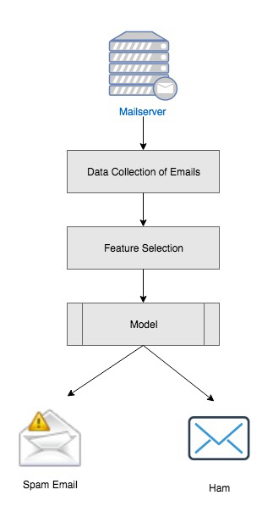

3.2.1 Flow Model Figure

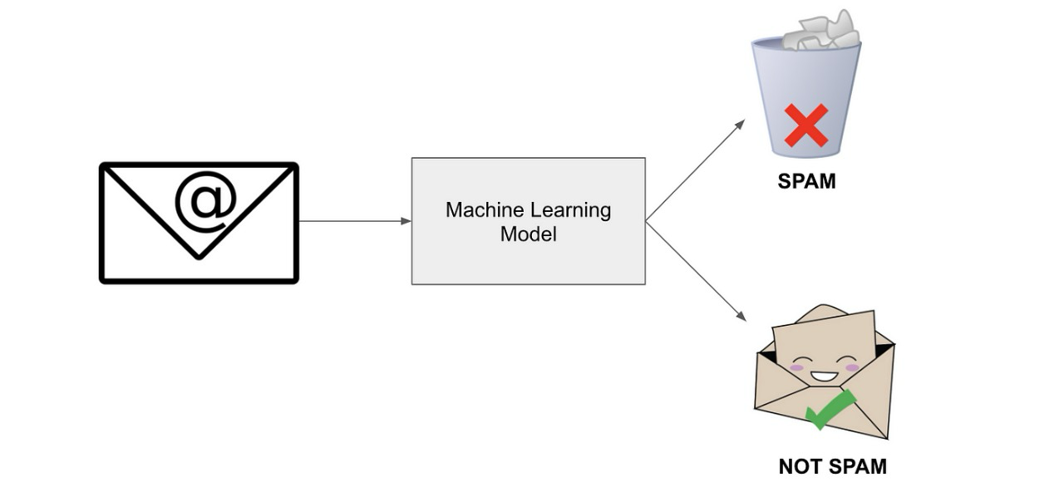

3.2.2 Machine Learning Model Figure

1. **RESULT**
   1. **CODE**

//PYTHON CODE//

1. **import** numpy **as** np
2. **import** pandas **as** pd
3. **from** sklearn.model_selection **import** train_test_split
4. **from** sklearn.feature_extraction.text **import** TfidfVectorizer
5. **from** sklearn.linear_model **import** LogisticRegression
6. **from** sklearn.metrics **import** accuracy_score
7. df = pd.read_csv("C:\\Users\\bharath kumar\\Downloads\\mail_data.csv")
8. print(df)
9. data =df.where((pd.notnull(df)),'')
10. data.head(10)
11. data.info()
12. data.shape
13. data.loc[data['Category'] == 'spam', 'Category'] = 0
14. data.loc[data['Category'] == 'ham', 'Category'] = 1
15. X = data['Message']
16. Y = data['Category']
17. print(X)
18. print(Y)
19. X_train,X_test,Y_train,Y_test = train_test_split(X,Y, test_size = 0.2, random_state = 3)
20. print(X.shape)
21. print(X_train.shape)
22. print(X_test.shape)
23. print(Y.shape)
24. print(Y_train.shape)
25. print(Y_test.shape)
26. **from** sklearn.feature_extraction.text **import** TfidfVectorizer
27. feature_extraction = TfidfVectorizer(min_df=1, stop_words='english', lowercase=**True**)
28. X_train_features = feature_extraction.fit_transform(X_train)
29. X_test_features = feature_extraction.transform(X_test)
30. Y_train = Y_train.astype('int')
31. Y_test = Y_test.astype('int')
32. print(X_train)
33. print(X_train_features)
34. print(Y_train)
35. model = LogisticRegression()
36. model.fit(X_train_features,Y_train)
37. prediction_on_training_data = model.predict(X_train_features)
38. accuracy_on_training_data = accuracy_score(Y_train, prediction_on_training_data)
39. print('Acc on training data: ',accuracy_on_training_data)
40. prediction_on_test_data = model.predict(X_test_features)
41. accuracy_on_test_data = accuracy_score(Y_test, prediction_on_test_data)
42. input_your_mail = ["SIX chances to win CASH! From 100 to 20,000 pounds txt> CSH11 and send to 87575. Cost 150p/day, 6days, 16+ TsandCs apply Reply HL 4 info"]
43. input_data_features = feature_extraction.transform(input_your_mail)
44. prediction = model.predict(input_data_features)
45. print(prediction)
46. **if** (prediction[0] == 1):
47. print('Ham mail')
48. **else**:
49. print('Spam mail')
50. print('Acc on training data: ',accuracy_on_test_data)
51. input_data_features = feature_extraction.transform(input_your_mail)
52. prediction = model.predict(input_data_features)

**4.2 OUTPUT**

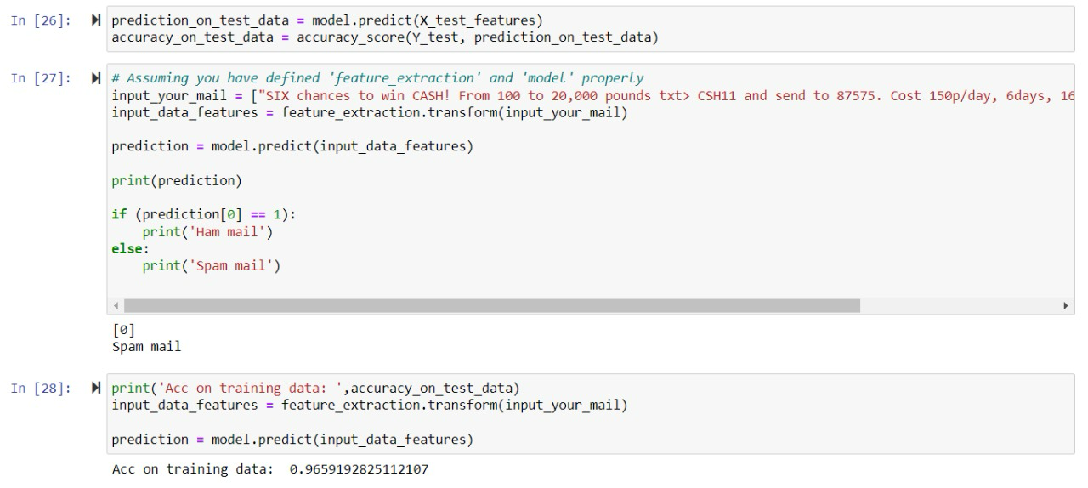

**5. CONCLUSION & FUTURE ENHANCEMENT**

**5.1 CONCLUSION**

In the ever-evolving landscape of digital communication, the battle against email spam remains a critical aspect of network security. This project set out to design and implement an email spam detection system that not only filters out unwanted and potentially harmful emails but also enhances the overall security of our digital ecosystem. Through an extensive methodology that included data collection, preprocessing, machine learning model development, and real-time analysis, this project aimed to address the growing threats posed by spam emails.

The implementation of the proposed system involved the careful selection of machine learning algorithms, comprehensive feature engineering, and continuous model training and evaluation. This approach allowed us to develop a sophisticated system capable of differentiating between legitimate and spam emails with a high degree of accuracy. By integrating sender reputation analysis, content analysis, user feedback mechanisms, and anomaly detection, we fortified our defenses against spam emails.

As this project progressed, it became evident that the fight against email spam is not static but rather a dynamic process that demands constant vigilance. The evolving tactics of spammers, the introduction of new threat vectors, and the shifting landscape of communication necessitate the continuous improvement and adaptation of email spam detection systems. We learned that a robust system must not only be technically proficient but also flexible and responsive.

User feedback, an essential component of our methodology, provided valuable insights into the system's performance, enabling us to refine its accuracy and minimize false positives and false negatives. Additionally, the integration with email servers and the implementation of real-time analysis allowed for swift and effective protection against emerging threats.

This project's contribution to the realm of network security goes beyond the technical aspects. It underscores the importance of user education, compliance with data protection regulations, and the establishment of a proactive security culture. It emphasizes that safeguarding digital communication is a collective effort in which both technology and user awareness play vital roles.

In conclusion, the development of an email spam detection system is not just a project but an ongoing commitment to network security. It is a testament to the resilience and adaptability of our cybersecurity efforts in the face of ever-changing threats. By remaining dedicated to the principles of continuous improvement, user empowerment, and compliance, we can create a safer digital environment for individuals and organizations alike.

This project serves as a foundation for further research, innovation, and collaboration in the field of email spam detection, as we continue to evolve in our quest for a secure and spam-free digital future.

**5.2 FUTURE SCOPE**

Advanced Machine Learning Models: Explore cutting-edge machine learning models, such as deep learning architectures (e.g., recurrent neural networks and transformers) and ensemble methods, to improve the accuracy of spam detection.

Zero-Day Threat Detection: Invest in systems that can identify and block zero-day threats by analyzing email content and behavior patterns to detect emerging spam tactics.

Natural Language Processing (NLP): Implement more sophisticated NLP techniques to better understand the context of email content, making it easier to distinguish between legitimate and spam messages.

Phishing Detection: Enhance the system to detect and mitigate phishing attempts, which often involve convincing but malicious email content.

Behavioral Analysis: Develop the capability to analyze the behavioral patterns of users and email senders to identify anomalies that may indicate spam.

Deep Packet Inspection: Integrate deep packet inspection (DPI) techniques to analyze email traffic at a more granular level, including attachments and embedded links.

Blockchain and Cryptographic Techniques: Explore the use of blockchain and cryptographic methods to enhance email security and verify sender authenticity.

Collaborative Filtering: Implement collaborative filtering techniques that consider the collective behavior and reports of users to identify spam patterns more accurately.

AI-driven Filtering: Utilize artificial intelligence to adapt to changing spam tactics in real-time, automatically adjusting the filtering parameters.

Multi-Layered Defense: Implement a multi-layered approach to spam detection that combines signature-based filtering, behavioral analysis, and machine learning models for a more robust defense.

**5.3 STUDY**

1. Literature Review:

Begin with a thorough review of existing literature on email spam detection, machine learning, and network security. This will provide you with insights into current research, methodologies, and technologies.

2. Define the Problem:

Clearly define the problem you aim to address with your project. Understand the challenges and intricacies of email spam detection and the impact of spam on network security.

3. Identify Goals and Objectives:

Set clear project goals and objectives. Determine what you aim to achieve with your email spam detection system and how it aligns with your organization's security requirements.

4. Data Collection and Preprocessing:

Study the process of collecting and preprocessing email data. Learn about data sources, data cleaning techniques, and data transformation.

5. Machine Learning Techniques:

Explore various machine learning algorithms and models commonly used in email spam detection, such as Naive Bayes, Support Vector Machines, deep learning models, and ensemble methods.

**6. REFERENCES**

**6.1 BOOKS**

"Machine Learning" by Tom M. Mitchell - This book provides a comprehensive introduction to machine learning, a fundamental component of email spam detection.

"Practical Machine Learning for Computer Vision" by Martin Görner, Ryan Gillard, and Valliappa Lakshmanan - A resource that focuses on machine learning techniques with practical applications in computer vision, which can be adapted to email content analysis.

**6.2 ACADEMIC PAPERS**

"A Review on Email Spam Detection Techniques" by Poonam Yadav and Poonam Tanwar - This academic paper provides an overview of different email spam detection techniques and their evaluation.

"Evasion Attacks on Email Spam Filter" by Blaine Nelson, Marco Barreno, Fuching Jack Chi, Anthony D. Joseph, Benjamin I. P. Rubinstein, Udam Saini, and J. D. Tygar - A paper that discusses evasion techniques used by spammers to bypass email spam filters.

**6.3 ONLINE RESOURCES**

The Spamhaus Project (spamhaus.org) - An invaluable resource for information on spam, spam sources, and real-time anti-spam data.

Anti-Phishing Working Group (apwg.org) - An organization that provides information and resources on phishing and email security.

MIT Technology Review (technologyreview.com) - A source for articles and news on emerging technologies and their impact on email spam detection.

Cybersecurity and Infrastructure Security Agency (CISA) (cisa.gov) - A government agency that offers resources and guidance on email security and cybersecurity best practices.

IEEE Xplore (ieeexplore.ieee.org) - A digital library for academic research papers on email spam detection and network security.